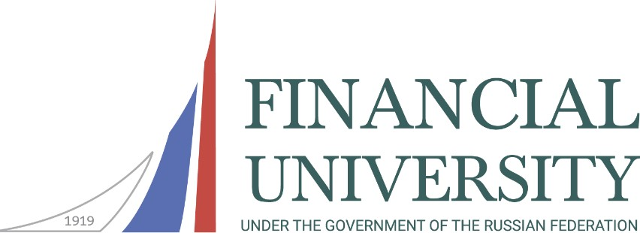

**Department of Humanities**

**Faculty of Social Sciences and Mass Communications**

International scientific and practical conference

**V Solovyov historical and philosophical readings**

**“Humanities and social processes: mutual influence and formation of development trajectories”**

November 30, 2024

Patriotism does not only mean

one love for one's homeland. It's much more...

This is the consciousness of one's inalienability

from the homeland and an inherent experience together with her, her happy and her unhappy days.

1. N. Tolstoy, Russian writer

**The purpose of the conference**: understanding and popularization of Russian historical experience, developing interest in the achievements of humanities and education in Russia and the world in the context of a philosophical and historical methods, defining modern concepts of educational and patriotic work with youth, scientific analysis of expected sociocultural changes in the conditions of modern geopolitical and social conditions in Russia and the world, studying the positive interaction of the educational system with the cultural spheres, determining the trajectories of domestic and foreign experience in the field of humanities and education, forecasting improved models of the education system to optimize educational practices and promote sustainable development of society.

**Participants:** We invite teachers, graduate students, undergraduates, students, workers in the field of education and educational management, as well as everyone interested in the development of humanities and society to participate in the conference.

**Format of meeting:** Offline meeting with the use of online technologies.

**Conference languages:** Russian, English.

**Topics of scientific events:**

***Plenary Session/Panel Discussion:***

***“To be a good teacher, you need to love what you teach and love those you teach”: this is where the main dynamics of the modern education system occur.” (V.O. Klyuchevsky, Russian historian)***

***Section 1.***

*Problems and philosophical issues of the Russian national intellectual tradition (on the 150th anniversary of the Russian philosopher and publicist N.A. Berdyaev).*

***Section 2.***

*Russian literature – to serve to the Fatherland and being a part of the world cultural heritage (on the 100th anniversary of Soviet and Russian writers V.P. Astafyev, B.L. Vasiliev, Yu.V. Bondarev, B.Sh. Okudzhava, Yu.V. Drunina, V.V. Bykov).*

***Section 3.***

*Achievements of Russian humanitarian science in the development of the country and society: from tradition to innovation (on the 300th anniversary of the establishment of the Russian Academy of Sciences).*

***Section 4.***

*Understanding the historical experience and ties of the peoples and regions of Russia (on the 10th anniversary of the reunification of Crimea with Russia).*

***Section 5.***

*The Legacy of the War Years: Achievements, Culture, and Everyday Life during the Second World War (on the 80th Anniversary of the Lifting of the Siege of Leningrad).*

***Section 6.***

*Historical Memory – an Interdisciplinary Construct and an Element of National Security (on the 100th Anniversary of the Founding of the State Central Museum of Contemporary History of Russia).*

***Solemn Meeting of the Scientific Student Circle "Philosophical Moscow":***

*"Intercultural interaction is the basis for the development and advancement of society."*

**Conditions for participation in the conference:**

***Travel, accommodation, and meals for participants are covered by the sending organization.***

***Remote participation in the conference is possible.***

Following the conference, there are plans to publish a collection of conference materials (ISBN) with article placement in «Russian index of scientific citation» or in the journal "Philosophy. History. Education" (https://fiojournal.ru/).

***Applications for conference participation are accepted until October 31, 2024,*** via email at [MNSvintsova@fa.ru](mailto:MNSvintsova@fa.ru) (please specify "Conference" in the subject). The participant's application should be completed in Russian and English.

***Materials for publication in the collection are accepted until November 15, 2024,*** via email at [MNSvintsova@fa.ru](mailto:MNSvintsova@fa.ru).

# Contact information:

Financial University under the Government of the Russian Federation

Department of Humanities of Faculty of Social Sciences and Mass Communications 125993, Moscow, Leningradsky Ave., 51/1, office 0619 (metro station "Airport") Phone: 8(495)249-52-99, e-mail: [MNSvintsova@fa.ru](mailto:MNSvintsova@fa.ru)***.***

Conference Coordinator – Ph.D. Svintsova Marina Nikolaevna.

# Sample application

**Application of the conference participant**

|  |  |  |
| --- | --- | --- |
|  | In Russian | In English |
| Name |  |  |
| Academic degree |  |  |
| Academic title |  |  |
| Place of work |  |  |
| Subdivision  (faculty, department) |  |  |
| Post |  |  |
| ORCID |  |  |
| Phone number |  |  |
| E-mail |  |  |
| Address (country, city) |  |  |
| Section |  |  |
| Report title |  |  |