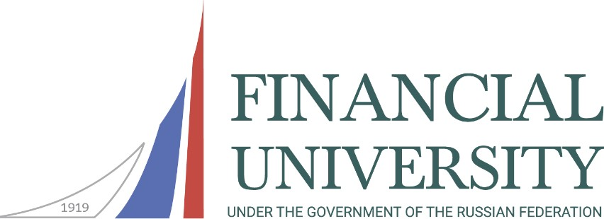

Department of Humanities of the Faculty of Social Sciences and Mass Communications

International Scientific and Practical Conference

IV Solovyov Historical and Philosophical Readings
"Sow the reasonable, the good, the eternal, Sow!" (N.A. Nekrasov). Education as a determining factor in societal development: experience and perspectives (towards the Year of the Teacher and Mentor in the Russian Federation 2023)

30 November-1 December 2023

Russia is renowned for its teachers.
The students bring glory to it.
A.D. Dementiev

The aim of the conference: The conference aims to promote Russian historical experience, generate interest in educational issues in Russia and globally through a philosophical, cultural, and historical approach. It seeks to define contemporary concepts of educational-patriotic work with youth, scientifically comprehend expected sociocultural changes in the conditions of modern higher education influenced by universal digitization in Russia and worldwide. The conference also focuses on studying the positive interaction between the educational system and the cultural space of new generations, determining the perspectives of domestic and foreign experiences, and exploring the potential of scientific-educational strategies in humanitarian education. Additionally, it aims to forecast enhanced models of the education system to optimize educational practices and contribute to the sustainable development of society.

Participants: We invite teachers, postgraduates, master's students, undergraduates, professionals in the field of education and educational management, as well as anyone interested in the development of humanities and society to participate in the conference.

Format of meeting: Offline meeting with the use of online technologies.

Conference languages: Russian, English.

Topics of scientific events:

Plenary Session/Panel Discussion:
"They are entrusted with an excellent duty, higher than which nothing else can exist under this sun" (Ya. A. Kamensky), within the framework of 2023 - the Year of the Teacher and Mentor in the Russian Federation

Section 1:
"To preserve memory, to cherish memory—this is our moral duty to ourselves and to future generations. Memory is our wealth" (D.S. Likhachev): traditional values, patriotism, and historical memory.

Section 2:
"The philosophy of Russia has always been a philosophy of the heart, a philosophy of the spirit" (D. Likhachyov): the domestic philosophical tradition.

Section 3:
"Russian culture is inseparable from the sense of conscience. Conscience is what Russia has contributed to global consciousness" (G.V. Sviridov): the cultural space of Russia.

Section 4:
"Patriotism, whoever it may belong to, is proven not by words but by deeds" (V.G. Belinsky): the experience of Russian regions in educational-patriotic work with youth.

Student Round Table 1:
"Ethics aims to imbue and fill the soul with internal integrity" (F. Bacon): the ethical dimension of the modern world.

Student Round Table 2:
"The best destiny is to defend one's homeland" (G.R. Derzhavin): heroic examples from Russian history.

Solemn Meeting of the Scientific Student Circle "Philosophical Moscow":
"Our Kant. Intersections and influences of German and Russian culture. On the 300th anniversary of the birth of Immanuel Kant".

Conditions for participation in the conference:
Travel, accommodation, and meals for participants are covered by the organizing party.
Remote participation in the conference is possible.
Following the conference, there are plans to publish a collection of conference materials (ISBN) with post-article placement in RSCI or in the journal "Philosophy. History. Education" (https://fiofa.ru/).
Applications for conference participation are accepted until October 31, 2023, via email at MNSvintsova@fa.ru (please specify "Conference" in the subject). The participant's application should be completed in Russian and English.
Materials for publication in the collection are accepted until November 15, 2023, via email at MNSvintsova@fa.ru.

Contact information:
Financial University under the Government of the Russian Federation
Department of Humanities of Faculty of Social Sciences and Mass Communications 125993, Moscow, Leningradsky Ave., 51/1, office 0619 (metro station "Airport") Phone: 8(495)249-52-99, e-mail: MNSvintsova@fa.ru.
Conference Coordinator – Ph.D. Svintsova Marina Nikolaevna.

Sample application

Application of the conference participant

 | In Russian | In English
Name
Academic degree
Academic title
Place of work
Subdivision
(faculty, department)
Post
ORCID
Phone number
E-mail
Address (country, city)
Section name
Theme of the report

You can familiarize yourself with author guidelines and publication material requirements on the conference website
http://www.fa.ru/org/dep/dgn/Pages/sr.aspx

