Federal State Educational Budgetary Institution of Higher Education
"Financial University under the Government of the Russian Federation"
(Financial University)

ORDER

« 05» October 2021 № 2085/0

Moscow

On approval of the Regulations for the preparation and defense of
the final qualification work performed in the form of a Start Up project

In order to form students' competencies corresponding to the types of professional activity, develop tools for involving them in innovative and entrepreneurial activities, mechanisms and forms of support and development of ideas, teams and projects, as well as in order to improve the quality of preparation of final qualification works at the Financial University, I order:
1. To approve the Regulations for the preparation and defense of the final qualification work performed in the form of a Start Up project, in accordance with the appendix.
2. Deans of faculties, Director of the Institute of Online Education:
2.1. Inform students of the 2nd-4th year of bachelor's degree and 1st year of master's degree (hereinafter referred to as students) about the possibility, advantages and features of the final qualification work ( next FQW), made in the form of a Start Up project
Deadline - 08.10.2021.
2.2. Organize the formation of expert groups to assess the feasibility of execution of FQW by the student in the form of Start Up project
2.3. Inform the Vice-Rector for Academic and Methodological Work Kameneva E.A. about the implementation of the thesis in the form of a Start Up project
The deadline is no later than the date of issuance of the order to assign the FQW topic to the student.
2.4. To propose the candidacy of the chairman of the state examination committee to conduct the defense of FQW in the form of a Start Up project.
The deadline is 01.12.2021.
2.5. Monitor the stages of implementation of the Start Up project and. informing the services and units involved in the organization and conducting state final certification, on the specifics and problems of implementing FQW in the form of a Start up project.
The deadline is 06.29.2022.
3. Heads of departments and heads of departments:
3.1. Provide conditions for the management (consulting) of the Start Up project, its preliminary examination and subsequent protection of the FQW in the form of a Start UP project.
The deadline is 02.06.2022.
3.2. Provide organizational and methodological support and control over the implementation of the FQW by the student in the form of a Start Up project.
Deadline - 20.06.2022.
4. Control over the execution of the order shall be entrusted to the Vice-Rector for Educational and Methodological Work Kameneva E.A.

Rector M.A Eskindarov

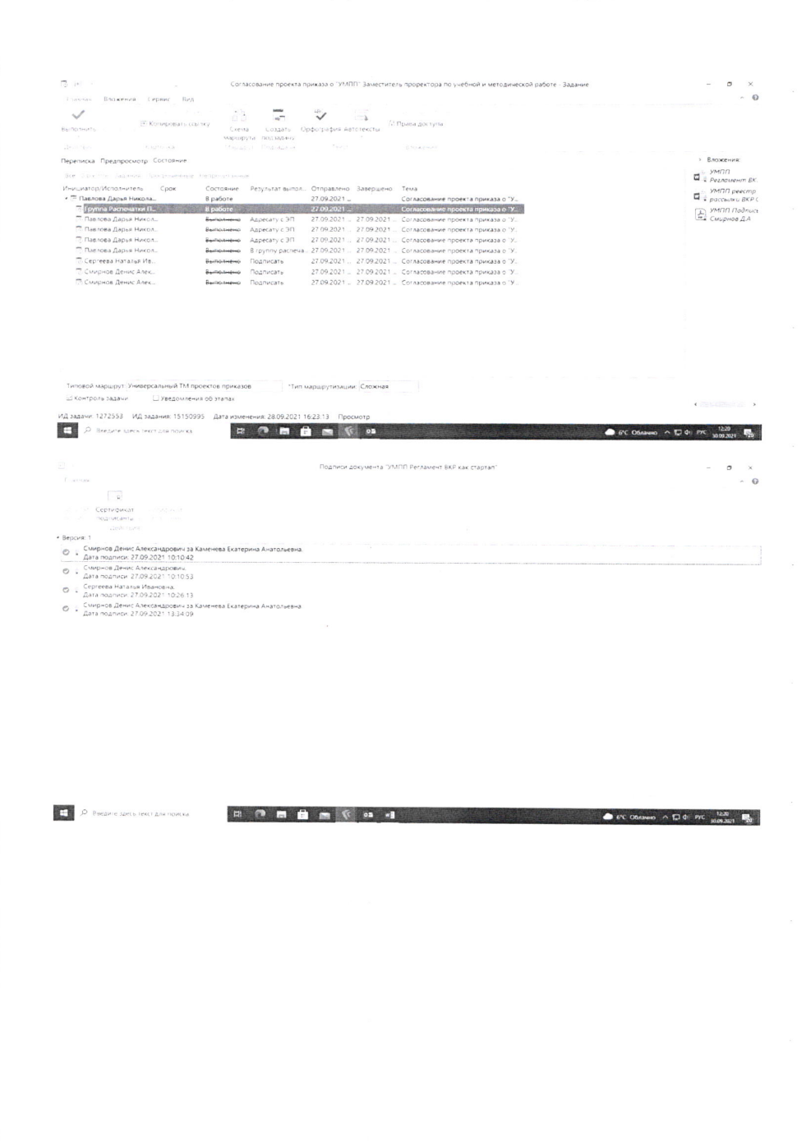

Application
APPROVED
by order of the Financial University
from 05.10.2021 № 2085/0

REGULATIONS
preparation and defense of the final qualification work,
made in the form of a Start Up project

1. General Provisions

1.1. The final qualification work (hereinafter referred to as FQW) is a form of state final certification (hereinafter referred to as SFE) and can be prepared and submitted for defense in the form of an entrepreneurial project Start Up project (hereinafter referred to as a startup).

1.2 A startup is a realized, innovative, entrepreneurial A project created by a student (or students) to search for an entrepreneurial opportunity and then develop and test a scalable economic model that demonstrates the level of preparedness of the graduate for professional activity and allows it to be evaluated.

The final qualification work in the form of a startup (next the FQW startup) is a formalized report on the main goals, objectives, provisions and results of the ongoing innovative entrepreneurial project developed by a student or several students (startup team), and demonstrating skills and abilities sufficient for independent professional activity and necessary for awarding the appropriate qualifications in accordance with federal state educational standards or educational standards of the Financial University.

1.3. The implementation of the project by the startup team involves the preparation for the defense of one work (report) with the reflection of the individual contribution of each team member. The individual contribution of the participant should be determined by the allocation of an independent subject of the project, the tasks (or) results of the project.

1.4. The main tasks of FQW in the form of a startup and the state final certification of students in the form of its protection are:
formation of students' skills in conducting innovative entrepreneurial activities, developing, promoting and financing a new product or new idea;
convergence of the formulated FQW topics with the realities of the current state of the market of ideas and products in the relevant subject area
formation of students' skills in communicating with external customers, investors and other market participants, as well as teamwork skills in the process of FQW-startup;
inclusion in the portfolio or resume of an FQW startup in the form of an innovative information product, increasing the relevance and relevance of scientific and applied developments and topics of applied research of departments (departments).

2. Criteria for classifying an entrepreneurial project as a startup

Not later than the issuance of the order on admission to the state final certification, the implementation of an entrepreneurial project and, accordingly, its attribution to a startup must be confirmed in one of the following ways:
2.1. In accordance with the legislation of the Russian Federation, a commercial organization has been established for students at the Financial University or they are personally registered as an individual entrepreneur, while the main activity of the organization (entrepreneur) must be directly related to the content of the project and the organization (individual entrepreneur) must have practical results that last until the defense of the FQW startup, for example, such as the current one a prototype of a product or a minimum viable version of a product (MUR), confirmed by the first sales of a given commercial organization or individual entrepreneur.
Similar requirements for the results are imposed on students who are not registered as individual entrepreneurs, but apply the special tax regime "Professional Income Tax", in accordance with Federal Law No. 422-FZ of 27.11.2018 "On Conducting an Experiment to Establish a Special Tax Regime "Professional Income Tax" (hereinafter referred to as self-employed persons).
Supporting documents are copies of the charter and (or) constituent documents, or an extract from the unified state register of legal entities (extract from the unified state register of individual entrepreneurs) of the Federal Tax Service of Russia, a copy of the patent (scan of the personal account of a self-employed person), as well as a report on product sales (unloading sales figures from the personal account of a self-employed person).
2.2. The student is a participant in the project of professional investors (business angels, venture funds), a participant in acceleration programs of large companies (banks, other investors), or is a participant in the grant program of the Financial University or a participant in the life cycle management program of an innovative and entrepreneurial project of the Financial University (for example, a Business Incubator).
Supporting documents are copies of documents confirming the status of a professional investor or the fact of the implementation of the acceleration program (for the programs of the Financial University - a certificate from the head of the grant program), an agreement with an investor or accelerator indicating the last name, first name, patronymic of the student, indicating the receipt of funding for a startup (another document indicating the last name, first name, patronymic of the student, confirming his participation and role in the startup), as well as Be sure to copy the documents confirming the fact of the implementation of the startup and its positive economic results.
2.3. Students are recipients of state (regional, municipal) grants (subsidies) received for the implementation of this entrepreneurial project, grants under programs of specialized institutes and foundations, such as: "Agency for Strategic Initiatives to Promote New Projects", "Skolkovo Foundation", "Foundation for Assistance to Small Innovative Enterprises" (Foundation for Assistance to Innovations), "Internet Initiatives Development Fund", as well as recipients of funds for implementation of this entrepreneurial project within the framework of other state and non-state programs (for example, the "Umnik" program);
Supporting documents are copies of approved grant applications and (or) contracts with development institutions and other organizations indicating the last name, first name, patronymic of the beneficiary, indicating the receipt of funding for the startup, as well as copies of documents confirming the fact of the implementation of the startup and its positive economic results.
2.4. Students are part of the startup team (they work under the terms of an employment contract in positions directly related to the creation, production and promotion of products), which has the status of participants in the project for the implementation of research, development and commercialization of their results in accordance with Federal Law No. 244-FZ of 28.09.2010 "On the Skolkovo Innovation Center".
Supporting documents are copies of certificates of inclusion of the company in the list of residents of the technopark, copies of the document confirming the participation of the student in the project of the resident company (contract for the performance of works, services, employment contract, etc.), as well as copies of documents confirming the fact of the implementation of the startup and its positive economic results.

3. Conditions and features of preparing an FQW startup

3.1. The student can propose as an FQW topic a startup that has been implemented or is planned for implementation (before the start of SFE).
3.2. The deadlines for choosing the topic of an FQW startup, the procedure for fixing the topic and the supervisor, submitting the work for defense, the procedure for appealing based on the results of the defense, as well as other elements of the preparation and defense of the FQW that are not specified in these regulations are established by the regulations on the final qualification work for the bachelor's program at the Financial University or the regulations on the final qualification work for the master's program at the Financial University (hereinafter referred to as the Regulations on FQW).
3.3. The student submits an application to the head of the department (head of the department) in the form in accordance with the appendix to the Regulations and a presentation of the project idea within the established time limits. The presentation should reflect: the problem, tasks, target audience, solution, expected results, initiator or project team.
When a project is implemented by a startup team with students at different faculties, each student submits an application to the head of the department (head of the department), who is the graduating student for the educational program. At the same time, the application lists all members of the startup team with an indication of the group and faculty at which they study.
3.4. The department (department) evaluates the submitted application and decides on the possibility of the student performing FQW in the form of a startup.
The decision in this case is made by a temporary Expert Group specially created in the department (at the department) (interdepartmental, interdepartmental), which, in addition to the employees of the department (department), may include business representatives (partners of the PLO), the business incubator of the Financial University, as well as persons with entrepreneurial experience. The task of the Expert Group is to assess compliance with the main criteria of a startup and/or the likelihood of achieving such compliance by the time the FQW is protected. The composition of the Expert Group and the number of its members is determined by the head of the department (head of the department).
By the decision of the dean of the faculty (in the branch - the director of the branch), one Expert Group can be created at the faculty, without creating an Expert Group in the department (at the department).
3.5. The decision of the Expert Group on the possibility of the student performing FQW in the form of a startup and fixing the FQW topic on the basis of an entrepreneurial project implemented or planned for implementation is reflected in the visa of the head of the department (head of the department) on the student's application and is the basis for the preparation and issuance of an order to assign the topic to the student and the head of the FQW startup (if necessary, a consultant).
3.6. The head of the FQW-startup (hereinafter referred to as the head) directly manages the startup and is appointed from among the teaching staff of the department (department) (in the branches - the corresponding structural subdivision). The manager must have practical experience in the organization and management of business and (or) the implementation of business projects (experience in managing a unit engaged in the development of entrepreneurship, innovative developments), or having at least 3 years of experience in teaching disciplines in the field of entrepreneurship, innovation or project activities.
In the case of a startup, the team appoints one manager (in the case of the implementation of the startup by students of different directions, it is possible to appoint a co-leader), who issues and signs the FQW assignment to each member of the startup team.
The rights and obligations of the head of an FQW startup are defined by the FQW Regulation.
3.7. An FQW startup consultant is assigned to the student (startup team) by the head of the department (head of the department) to assist, accompany and assist in the implementation of both the project itself and the FQW startup. The consultant is appointed from among business representatives, practitioners – partners of the educational program, representatives of the Business Incubator of the Financial University or other interested structures of the Financial University.
3.8. The main attention in an FQW startup should be aimed at revealing the essence of the entrepreneurial project, its innovativeness and implementation mechanisms, revealing the use of practical skills in solving an entrepreneurial problem. The disclosure of the essence of a startup, as a rule, should be accompanied by a reflection in the report:
the object and subject of research, as well as the goals and objectives of the project;
research (analytics) of the market to which the startup is launched;
justification of the entrepreneurial idea and the mechanism for its implementation, including sources of financing, financial mechanism, financial support instruments, etc.;
the essence of the new product (service) constituting the main activity of the startup and additional activities;
justification for the promotion of the product (service);
plan of sales dynamics in the context of products (services) and geography of markets;
assessment of financial results.
It is also advisable to reveal knowledge of the theory of entrepreneurship and the basic concepts of entrepreneurial activity.
3.9. An FQW startup should include the following sections: title page, table of contents, introduction, main part, conclusion, list of sources used, applications.
3.10. In the introduction, a student who is a participant in a startup (startup team) reveals the relevance of the project (topic), its development, purpose, objectives, object and subject of research, and the range of problems under consideration.
The main part of the WRC startup should be structured and can be divided into sections, chapters and (or) paragraphs.
Depending on the specifics of the project (innovative idea) or the features of its implementation, the first part briefly reveals the theoretical provisions of the innovative idea, its capabilities and directions for implementation, for example, a theoretical overview of the applied concepts of entrepreneurship and tools for identifying the possibility of implementing this entrepreneurial idea, a practical approach to choosing an entrepreneurial idea and analyzing alternative options, a general idea of the business model for A. Osterwalder or similar, market overview and justification of the size of the target market.
The second part is entirely devoted to the work on the creation and implementation of an entrepreneurial project. In particular, it is advisable to disclose a description of the work on the creation of a minimum viable product (MUR), including hypotheses regarding the characteristics of the product and the results of their confirmation, as well as the subsequent testing of the MUR, a description of actions to create a startup (principles of choosing an organizational and legal form, registration of the formation of conditions for operating activities, financing, identification of sources of funding, etc.), description of actions on the formation of the internal environment of the organization, a description of the marketing mix and the organization of the first sales, an assessment of the achieved economic results and a forecast of financial and economic indicators. At the end of this part (as an option the third part (section, chapter), directions for the further development of the startup are proposed, directions for solving the problems identified during the implementation of the startup are substantiated, specific proposals for scaling the proposed business are formulated.
3.11. The volume of an FQW startup, as a rule, should not exceed 50 pages without applications. When a startup is performed by a team, the volume can be increased to 65-70 pages.
In the case of a startup by a team, in the second (third, if any) part (chapter), it is necessary to reflect the individual contribution of each team member in such a way that the project manager, as well as members of the state examination commission, can evaluate the individual contribution of each student in the implementation of the FQW startup.
3.12. The appendices must contain the results confirming the compliance of the work with the FQW startup criteria provided for in section 2, as well as the results of surveys, interviews and other actions related to selection and justification of the idea, development and implementation of the project, its promotion on the market.
Appendices may include additional reference materials necessary for the completeness of the study, but of auxiliary importance, for example, copies of documents, excerpts from reporting materials, statistical data, diagrams, tables, diagrams, programs, detailed calculations, descriptions, etc.
3.13. Based on the results of the prepared work, the head of the FQW startup submits a review of the student's work (a separate review for each student on joint work, taking into account the individual contribution of each student) during the implementation of the startup.
3.14. FQW startup is subject to mandatory peer review (at least one review from an expert in the relevant field of professional activity, depending on the direction of training). Reviewers, as a rule, should be persons whose activities correspond to the focus of the startup, as well as practitioners - experts in the relevant field of professional activity.
The review is submitted to the department (department) for further placement on the org.fa.ru platform, which is part of the electronic information and educational environment of the Financial University (hereinafter referred to as the platform) no later than 5 calendar days before the defense of the FQW-startup.
3.15. The department (department) organizes the pre-defense of an FQW startup no later than | a week before the start of the state final certification. For pre-defense, the student submits a presentation project that briefly reveals the essence and main provisions of the FQW startup, the goals, objectives, provisions of the ongoing entrepreneurial project developed by the student or several students (startup team) with an indication of the preliminary results of its implementation.
The pre-defense is carried out with the invitation of the members of the Expert Group who took part in recommending the implementation of the startup FQW by the student.
3.16. Upon successful completion of the pre-defense, the student is given recommendations on finalizing and taking into account the comments received during the pre-defense, as well as setting a deadline for loading the FQW startup on the platform and submitting its electronic version and presentation for submission for review.
Based on the results of the pre-defense, the student may be recommended to further perform the FQW in the traditional format. In this case, the student is obliged to finalize the thesis in accordance with the FQW Regulations. At the same time, the terms of approval of the FQW prepared in the traditional format and the terms of placement (loading) of the FQW on the platform are extended, the specific date of loading is determined by the commission, but cannot be set later than 5 days before the defense.
3.17. Placement (loading) of an FQW startup is carried out in accordance with the Regulations for the placement, storage and write-off of final qualification works of students in electronic form in the information and educational environment of the Financial University.
3.18. The report on the completed startup is subject to mandatory verification for illegal borrowings in the "Anti-plagiarism. UNIVERSITY". In case of detection of borrowings in the amount of more than 20%, the head of FQW conducts
analysis of the text for compliance with the norms of lawful borrowing and decides on the legality of using the borrowed text in an FQW startup.
3.19. After placing the prepared FQW startup on the platform, the manager draws up a written review of the student's work during the preparation of the work and places it on the platform.

4. Features of the procedure for protecting a thesis
in the form of a startup and criteria for its evaluation

4.1. The procedure for defending an FQW startup is carried out in accordance with the Regulations on the Thesis, and also provides for the speech of the reviewer (reviewers) of the FQW startup or, in case of his (their) absence, hearing the text of the reviews.
4.2. In order to organize the protection of the FQW by the startup team with students of different directions at the Financial University, one state examination commission is formed, including practitioners of the relevant areas of training, as a rule, with experience in innovative entrepreneurial activity, development, promotion and financing of a product or idea, chaired by a specialist with practical experience in organizing and managing a business and (or) implementation of business projects.
4.3. The protection of FQW by the startup team is carried out sequentially by each team member in accordance with the prescribed roles of the participants, including questions from the members of the startup commission and the report of each team member.
4.4. The basic criterion for evaluating an FQW startup is the stage of project implementation (for example, signing a project agreement and allocating funding, bringing the product to the market, selling the product and making a profit, etc.).

Deputy Vice-Rector
on educational and methodical work D.A Smirnov

Appendix to the Regulations

Sample
statements on the consolidation of the topic of the thesis in the form of the implementation of an entrepreneurial project (startup)

FINANCIAL UNIVERSITY Head of Department /
Head of the Department________________
(name)
_________________________________ ____________________________________________
(name of department/department) (Surname, academic degree, academic title)

________________________________
AGREED (surname of the acting student)

________________ ______________________ ____________________________________________
(signed) (surname) (name of faculty)

«_____» _________20___Y _____________________________
(No. of the study group)
Tel________________________________________
E-mail______________________________________
APPLICATION
I ask you to assign to me the topic of the final qualification work in the form of the implementation of an entrepreneurial project (startup)

«_________________________________________________________________________»
(name)
The participants of the startup are graduate students*:
1_________________________________________________________________________
(surname of the acting, number of the study group, name of the faculty)

2___________________________________________________________________________
(surname of the acting, number of the study group, name of the faculty)

With the Regulations on the final qualification work on the bachelor's / master's program of the Financial University, the Regulations for the preparation and defense of the final qualification work, made in the form of a Start Up project, as well as the Regulations for the placement, storage and write-off of course projects (works) and final qualification works of students in electronic form in the information and educational environment of the Financial University (a). Appendix: justification of the expediency of development for practical application in the relevant field of professional activity in the form of a presentation on a sheet (s).

«_____» ___________202____y ______________ Surname
signature

_______________________________
The visa of the head of the department (head of the department) is put after a positive decision Expert group on the results of the discussion.
Agreed:
Head of FQW Startup

________________ ____________________
(Signature ) (Surname)

«_____» _____________ 20__y

Participants are listed if the project is implemented by the startup team.

