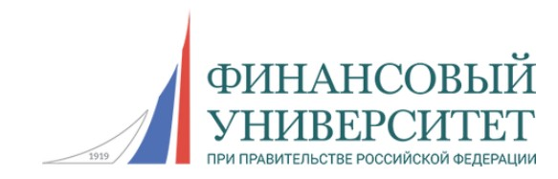

**Program of the round table**

«***Anti-money laundering, compliance control, financial investigations***»

**December 18, 2024**

**16.00 - 18.00**

**Link to connect:** https://us06web.zoom.us/j/83528201727?pwd=YpoloOBvQzGpZ97J2m3ahlzbamjghF.1

**Conference ID:** 835 2820 1727

**Access code:** 569292

The working conference language - English

**Welcome speech:**

|  |  |
| --- | --- |
| **Ekaterina A. Kameneva** | Vice-Rector for Academic and Methodological Work, Doctor of Economics, Professor, Financial University |
| **Fabio Krykhtine** | Special Coordinator of International Affairs for Russian Federation, Professor, Federal University of Rio de Janeiro |

**Moderators**

|  |  |
| --- | --- |
| **Fabio Krykhtine** | Professor of the Department of Industrial Engineering Polytechnic School, Federal University of Rio de Janeiro |
| **Igor A. Lebedev** | Head of the Department of Economic Security and Risk Management, Financial University |

**Speakers:**

|  |  |
| --- | --- |
| **Fabio Matos Correa**  **(under confirmation)** | Prosecutor Court – State of Rio de Janeiro  ***Topic of the report*** – “An Overview about Financial Crimes at Rio de Janeiro” |
| **Dmitry V. Nikitin** | Associate Professor (Practitioner) of the Department of Economic Security and Risk Management, Financial University  National Compliance Association, expert council member  ***Topic of the report*** - "Fraud and corruption risk transformation in terms of digitalization» |
| **Stanislav V. Popov** | Associate Professor (Practitioner) of the Department of Economic Security and Risk Management, Financial University  ***Topic of the report*** - "Implementation of new technologies in AML/KYC compliance process» |
| **Paulo de Oliveira Reis Filho, D.Sc.** | Associate Researcher at Fuzzy Logic Laboratory, Federal University of Rio de Janeiro  ***Topic of the report*** – “Risk & Security as a Service – RSaaS” |
| **Eduard Ashrafyan** | Senior Lecturer (Practitioner) in the Department of Business Informatics, Financial University  Advisor to the CEO of “Price Express”  ***Topic of the report*** - Integrating GPT into business operations |
| **Anna D. Gracheva** | master level student, Financial University  ***Topic of the report*** – «The problems of drug trafficking using cryptocurrencies»  Supervisor – professor Igor A. Lebedev |
| **Mateus Faria Leite Ferreira** | Bachelor Student, Federal University of Rio de Janeiro  ***Topic of the report*** – “Sports Betting as an instrument for carrying out financial crimes”  Supervisor – professor Fabio Krykkhtine |
| **Maria V. Maksimchenko**  **Anton V. Kondratyev** | master level student, Financial University  Leading specialist, Economics and Finance, Sibur  master level student, Financial University  Analyst, Investment Company  ***Topic of the report*** – «Sectoral assessment of money laundering (legalization) risks in terms of leasing companies»  Supervisor – professor Nadezhda V. Kapustina |